


Chalmers Memorial Church Newsletter
Christmas 2008



From the Minister:

As many of you know, I spent some of the formative years of my early life amongst the Border hills and for three years attended school in Langholm, the closest town. Weaving was then to the people of Langholm and the surrounding community what fishing was once to our community here and what mining was to the people of Newton, my first parish – almost every family was involved in one way or another. Decisions taken by those involved in the main industry affected everyone.

I recall the vote that was taken amongst the Langholm mill workers – they were entitled to a day off at either Christmas or New Year, which was it to be? I remember the lady who was organist at one of my father’s churches expressing her bitter disappointment that the vote had gone in favour of having the full day off on New Year’s Day. I’ve often wondered how, faced with the same choice, people would have voted now?

How things have changed in the 50 years since that vote was taken!
Many offices now close for the whole of the festive season – many workers take extra days holiday to give themselves a long break – and, for the saddest of reasons, many people this year will be having an extended break they never ever wanted as more and more firms are shedding jobs.

How would I have voted? Undoubtedly in those days I’d have voted for the Christmas full day’s holiday. Now?........ I’m not so sure.
Pastoral Cover
Rev Robert SIMPSON (01875 810308) will provide emergency pastoral cover from Monday 26th January until Monday 2nd February.

Christmas is now for almost everyone a time of busy-ness, and a Manse family knows not to expect much attention until after the last service is over, usually on Christmas Day. But New Year is different. There is time to be a family, time to relax and, perhaps most important of all, time to reflect.

Perhaps the Christmas people had 50 years ago was closer to that at the time Jesus was born. It was a day when people just went about their normal business.

Then again, perhaps the Christmas we have now is in certain respects closer to the situation at the time Jesus came into the world. His birth would go unnoticed and uncelebrated by the vast majority. People now seem to be so busy celebrating Christmas that they have little time to celebrate the birth of Christ.
Christ’s birthday goes unnoticed and uncelebrated in many Christmas celebrations still today.

As an example, have you noticed in recent years just how hard you have to look to find any genuine CHRIST-mas Cards in most of our shops and supermarkets? There might be at most one or two religious card selections, but in many shops there are none at all. Is this a deliberate policy on the part of card-makers and shop owners? In our multi-faith community, are people so scared to offend people of other faiths that Christ must be kept out of Christmas? Yet the odd thing is that it is often people of other faiths who express surprise that Christians make so little of their festivals.

MINISTER
Rev. Robert L Glover,
Braemar Villa, 2 Links Road, Port Seton
Tel: 812481
E-mail: rlglover@btinternet.com
(Please respect Monday as the Minister’s day off)

As Christians we still have many opportunities to let non-Christians know what Christmas really is about. If we really wanted, we could so plan our Christmas celebrations that we will make time to worship together at one or more of the special Christmas services. People will notice if our Church is busy – just as they will take note if Christ has no obvious part in our celebration.

Luke tells us that those who first saw the baby Jesus and recognised Him for the special child he was “spread the word concerning what had been told them about this child…. But Mary treasured up all these things and pondered them in her heart.” Luke tells us that while others rejoiced, Mary reflected.

With the exception of those of us working in the “service” industry and those working to provide emergency cover for essential services, the vast majority of us no longer have to choose between Christmas and New Year as did those mill-workers half a century ago. We can enjoy both – we can rejoice at Christmas and take time to reflect at New Year. Understandably, many of us, because of the circumstances of our lives right now will feel more inclined towards one than the other.

Whatever your circumstances, whether rejoicing or reflecting, my prayer is that you will feel the Presence, the Peace, the Hope and most of all the Love which God gave to the world in Christ that first Christmas and which He still gives to those prepared make room in their hearts and lives for Him today.
BOB

The next meeting of the Candle Coffee Club will be on Thursday 18th December.
Meeting at 10a.m. in Longniddry Inn.
This will be a
Christmas Special
All Welcome
There will be a Christmas Special in aid of C.H.A.S. on WEDNESDAY 3rd DECEMBER 10am – 2pm. There will be tea, coffee, mince pies and soup over lunchtime. Come along and enjoy some time with your friends. Donations of home baking would be most welcome. Please contact Sandra Donaldson (812023) or any member of the team
if you can help.



EDITOR'S NOTE
Thanks to all who have contributed to this issue of the Church Newsletter.
The next issue will be available on
Sunday 18th January 2009
Articles for this edition should be with me by
Sunday 4th January 2009
If you would like to E-Mail news you can contact me on: chalmerschurch@btopenworld.com
or by phone on 819471
Sheila Bulloch



IMAGINING THE BIBLE
We have just finished a series of 6 and for those who like to do this at home on their own the passages were:
Acts 12:1-17 Peter's release from goal.
Luke 19:1-10 The story of Zaccheus
Matt 20:1-15 First and last - imaging being
part of this parable.
Matt 15:21-29 Canaanite woman argues with Jesus
Luke 1:26-56
Matt 1:18-25 Announcing of the birth of Jesus,
Luke 2:25-52 Babyhood and boyhood of Jesus

We hope you get as much out of these stories as the people coming to the meetings.

It is planned that another series will be held from 3rd Feb – 10th March when the 'imaginings' will tie up with the Sunday Gospel readings

Sunday School News
The Sunday School party for children up to age 10 will be held on
Saturday 20th December in the
Church Hall from 2.30 pm to 4.30 pm.
Can parents of those children wishing to attend the party please give their names to Christine Baines (811583) or any other Sunday School teacher before December 13th.
There will be a presentation by the Sunday School at 11.00am service on 21st December.

Thanks
Alison, Mary, Ina and family would like to thank everyone for the flowers, cards, caring thoughts and prayers received following the death of Bill. The McNeish family would also like to thank Mr Glover as well as the ladies of the Guild for their hospitality.

Isabel Stirling would like to thank everyone for their thoughts, cards and flowers received following her recent stay in hospital.

BAPTISM
On 12th October Dean BINGHAM, 21 Johnston Terrace
FUNERALS
On 23rd October David McNEILL,
45 Thomson Crescent
On 30th October William (Bill) McNEISH,
90 Glassel Park Road, Longniddry
On 5th November Mrs Janet FRASER, 11 Castle Terrace
On 6th November Mrs Janet ALLAN, 62 Cedar Drive

HOME COMMUNION
Members who through illness or disability are unable to attend either of the forthcoming morning or evening communions and would like communion brought to them on the afternoon of Sunday 25th January are invited to speak to their Elder in the first instance or to telephone the Minister.

We welcome contributions to the Church Newsletter. Please note however that these may be edited, summarised or omitted by the minister and editor, as circumstances require. Letters of general thanks and acknowledgement for Church flowers will be posted on the notice board in the Church Hall.


Christmas Services
Sunday 21st December
11.00 a.m. Family Service with presentation by the Sunday School. With the BLESSING of
Keir Robert LAIDLAW
Followed by CONGREGATIONAL
CHRISTMAS LUNCH
6.15p.m. Christmas Music with the Choir

Wednesday 24th December (Christmas Eve)
6.00 – 7.00p.m. Family Carol Service –
'Come when you can - Leave when you must'
11.30 p.m. Watchnight Service

Thursday 25th December (Christmas Day)
11.00 a.m. Short Family Service

Sunday 28th December - Services for the Years End
11.00a.m. Morning Worship
Please note NO 10.15am or 6.15pm services

Boys Brigade Christmas
Card Delivery Service
The post box for Christmas cards will be in the Church vestibule after all services
Cards will be collected from the box on
7th, 14th and 21st December.
Each card costs 20p for deliveries within Cockenzie and Port Seton ONLY.

Congregational Christmas
Family Lunch
This will be served after
the Family Service on
Sunday 21st December in the hall.
Tickets will be available in the Hall
from 7th December
£3adults / children free with an adult.

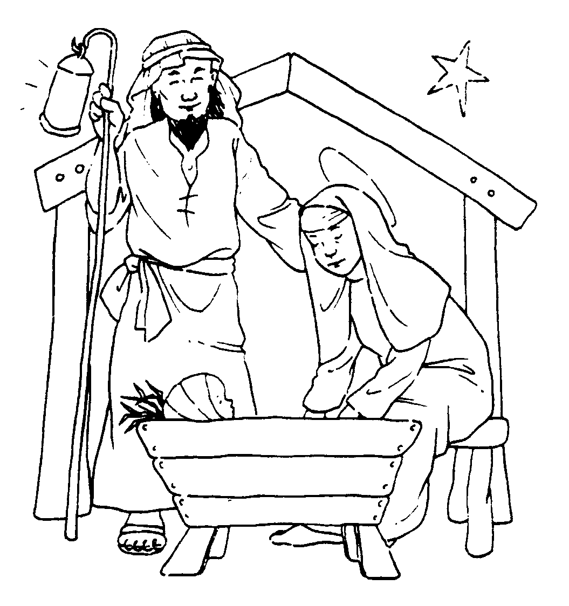



“I am the light of the world. Whoever follows me will never walk in darkness, but will have the light of life” John 8 v. 12

.

On behalf of CLIC Sargent –There is to be a concert, performed by the choir of the Lothian Hospitals professional staff, conducted by Tim Dean, Esq., of Scottish Opera, on Thursday 18th December
at 7.30pm, in The Church of Scotland Assembly Hall on The Mound, Edinburgh.
Tickets may be obtained, at £10 and £7 for children, form The Tickets Scotland Office, 127, Rose Street, or by calling 0131 220 3234 or Hamish Alldridge on
07968 098939.

“Rejoice and be glad! The Redeemer has come”
Heavenly Father at this Christmas Season we come before you with grateful hearts to thank you for sending into the world Jesus who came to be our Saviour and Lord. Forgive us Lord that we fail so often to follow your commands to love one another. Help us by the power of your Holy Spirit at this Christmas time to put Jesus centre in all we do and to give you the honour and glory due to your Name. Amen

Give thanks for all that gone on in your life throughout this past year, the love we have experienced in times of sadness, the joys we have shared in the time of rejoicing and above all the wonderful occasions we have felt the nearness and comfort of our Heavenly Father.

Remember those known to us in our Church fellowship, our neighbours or workmates for whom this Christmas time is a time of great sadness as they mourn the loss of a loved one. Ask God to be very near to them that they may feel his comforting presence. Pray also for those who are ill and those who worry abut them, for those who are lonely and our old folks who are now living in Homes.

Bring before God all who govern our country at this time of great financial difficulties worldwide. Pray that they may be given wisdom to make right decisions. Pray for ourselves that we may not be caught up so much with the cost of Christmas that we forget peoples in the world who cannot even buy food.

As Christmas is a time for children, bring before God children in Belarus who will be receiving our boxes. Pray that they may feel the warmth of God’s love as they receive the boxes. Remember especially John and Lyn as they deliver our Church’s boxes in Belarus.

Pray that the celebrations at Christmas will serve to remind people in our community of the important Christian tradition we share; that many will think seriously about who Jesus was and His claims on our lives today.

Please pray for each service that is held to celebrate Christmas and honour Christ; that God will be with our minister and all who communicate the Good News of the Emmanuel – God with us.

News from World Mission:
Zimbabwean Christians vow prayer offensive until crisis ends Zimbabwean
Christians have vowed to press on with weekly prayer vigils "until something happens" after efforts at forming a unity government to resolve the country's economic and political crisis faltered.

Prayers for Bethlehem during
Advent and Christmas
As many Christians around the world prepare to celebrate Advent and Christmas in the security of their homes and communities, they are invited to pray for justice, peace and security for Palestine and Israel

The WCC says, “Once again this year, Christmas celebrations will take place in a difficult climate for people in the Holy Land. However, Bethlehem, the birthplace of Jesus, is still first and foremost a city of peace. And even in these trying times, many individuals and groups living there refuse to give up hope. They continue to search for non-violent ways to voice their rights and work for a peaceful and just future for both Palestinians and Israelis.”

Services and Meetings

Sunday
10:15 a.m. All-age Family Worship (in Hall)
Followed by Sunday School & Rock Club Groups
11.00 a.m. Morning Worship (with Crèche)
6:15 p.m. Evening Worship
(As advertised, usually last Sunday of month)
7:30 p.m. Rock Solid Club (every 2nd week)

Monday
7:15 p.m. The Guild (Oct - March)

Tuesday
7.30 p.m. Bible Study

(As advertised)

Welcome Wednesday
10a.m – 12noon Coffee Time (1st)
12-2p.m. Chalmers Lunches (3rd)
10 - 11a.m. Prayer Time (last)
5:15 p.m. 1st Port Seton Rainbows (Sept. - June)
6:30 p.m. Boys Brigade –
Anchor boys and Junior Section
7:45 p.m. Company Section (Sept. - June)
8.00p.m. Badminton Group

Thursday
5:00 p.m. Rainbows}
6:30 p.m. Brownies } (Sept. - June)

Saturday
8.00 – 9.15a.m Prayer Breakfast (last of month)
6:30 – 7:45 p.m Youth Club for 8-10 yr olds
8.00 – 9:15 p.m Youth Club for 11yrs +
(Meets every 2nd week Sept-June)

OUR WORSHIP - (Services led by Rev Bob GLOVER except where indicated)
Sunday 7th December (2nd in ADVENT)
10.15 a.m. All-Age Worship with
Amanda JOHNSTON
11.00 a.m. Traditional Worship.
The Moderator of Lothian Presbytery

Sunday 14th December (3rd in ADVENT)
10.15 a.m. All-Age Worship
11.00 a.m. Traditional Worship.

Services for the Christmas Season –
See Details on Page 3
Retiring Offerings for
TEAR FUND
at the Christmas Services

Sunday 28th December
(N.B. No 10.15 a.m. Service this Sunday)
11.00a.m. Service for the Last Sunday of the Year

2009
Sunday 4th January (N.B. No 10.15 a.m. Service this Sunday)
11.00a.m. Service for the First Sunday of the Year.
Duncan MORGAN

Sunday 11th January (N.B. No 10.15 a.m. Service this Sunday)
11.00a.m. Presbytery of Lothian
“Souper Sunday” in conjunction with The Church of Scotland’s HIV/AIDS Project Elders’ Service (followed by Fund-Raising Lunch in the Hall)
Sunday 18th January
10.15 a.m. All-Age Worship
11.00 a.m. Traditional Worship. Rev Bob GLOVER

Sunday 25th January
10.15 a.m. All-Age Worship with David COOPER
11.00 a.m. Traditional Worship. Rev Bob GLOVER
Sacrament of HOLY COMMUNION (with Crèche)
6.15 p.m. Evening Worship followed by brief celebration of HOLY COMMUNION

Sunday 1st February
10.15 a.m. All-Age Worship
11.00 a.m. Traditional Worship. Rev Tom GORDON

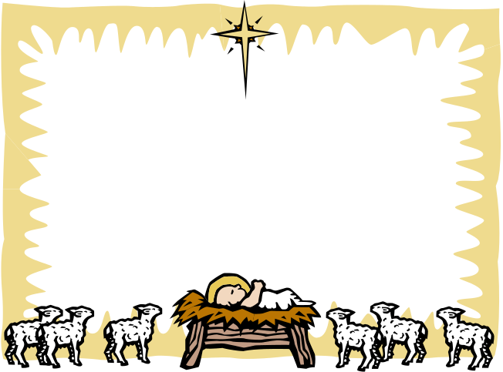
MINISTER SESSION CLERK CLERK TO DEACONS COURT
Rev. Robert L Glover Mr John Murdoch Mr Ian Bulloch
Tel: 812481 Tel: 812469 Tel: 852717
TREASURER ACCESS to the HALL contact BEADLE
Mrs Janet Farquhar Mr Tom Donaldson Mr Duncan Morgan
Tel: 811863 Tel: 812023 Tel: 812071
FLOWER CONVENER ORGANIST PRAYER SECRETARY
Miss Mary Clements Mrs Pamela Zenati Mrs Alice Hood
Tel: 812241 Tel: 813641 Tel: 812191
 Please recycle this newsletter and care for the earth as God intended
SC004630 Cockenzie and Port Seton: Chalmers Memorial Parish Church 'Scottish Charity'.

